**AZURE STORAGES**

**Azure Blob Storage**

* Object storage for unstructured data (like images, videos, backups, logs).
* **Use cases:**
  + Storing large amounts of unstructured data
  + Data lakes for analytics
  + Media streaming (audio/video)
  + 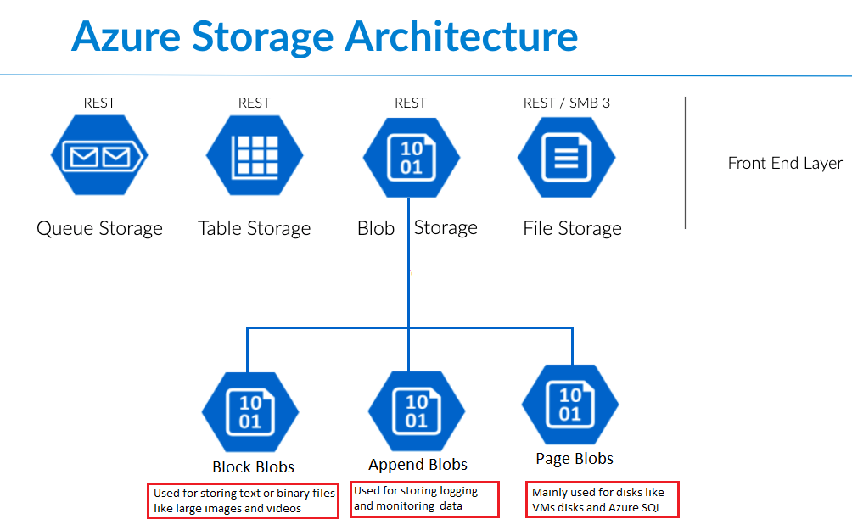Backup & disaster recovery

**Azure File Storage**

* Fully managed file shares in the cloud, accessible via SMB (Server Message Block) protocol.
* **Use cases:**
  + Lift-and-shift migration (move old apps that need file shares)
  + Shared drives across multiple VMs or on-prem systems
  + Centralized storage for applications

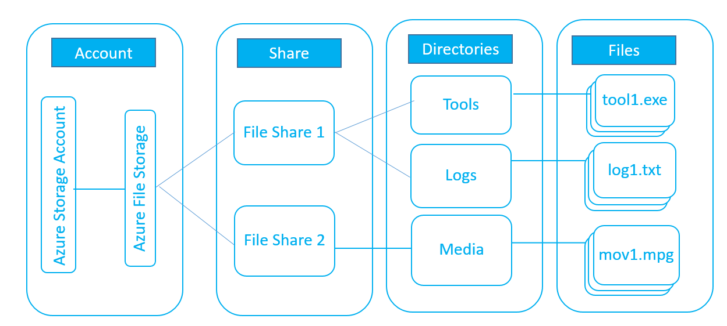

**Azure Table Storage**

* A NoSQL key-value store for semi-structured or structured data.
* **Use cases:**
  + Storing large datasets with flexible schema
  + Storing IoT device metadata
  + Web app user profiles, catalogs, logs

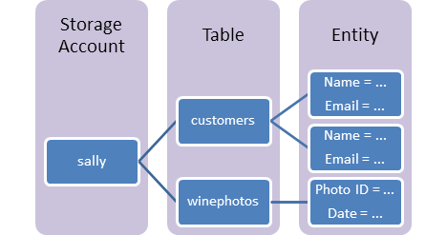

**4. Azure Queue Storage**

* A messaging service for communication between distributed applications.
* **Use cases:**
  + Decoupling components in cloud apps
  + Task scheduling (e.g., order processing, email sending)
  + 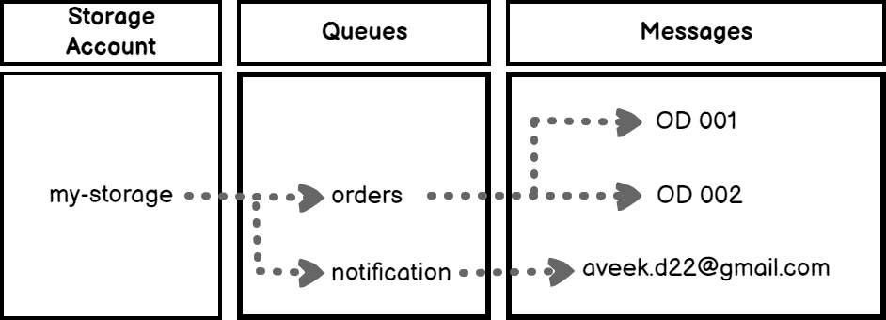Message queue between microservices

**COMPARISION:**

| **Storage Type** | **Data Type** | **Access Protocol** | **Best For** |
| --- | --- | --- | --- |
| Blob Storage | Unstructured (text, images, video, logs, backups) | REST API, SDKs | Big unstructured data, backups, streaming |
| File Storage | Files & folders | SMB, NFS | File shares, legacy apps, shared drives |
| Table Storage | Structured (NoSQL key-value pairs) | REST API, OData | Metadata, catalogs, IoT data |
| Queue Storage | Messages (text data up to 64KB each) | REST API, SDKs | Message passing, task queues, async processing |